Sunday | Monday | Tuesday | Wednesday | Thursday | Friday | Saturday
2 | 3 | 4 | 5 | 6 | 7 | 8

TV Channel 1970 Programing

11:00  Ginger Cove Church Service  (1 Hour)  1:00  “TGC”- Worlds Important Churches  Ep. 1&2  (1 hour)  4:00  “TGC”- The Cathedral  Ep. 1&2  (1 hour)  6:00  Andre Rieu Concert Series  (2hrs)  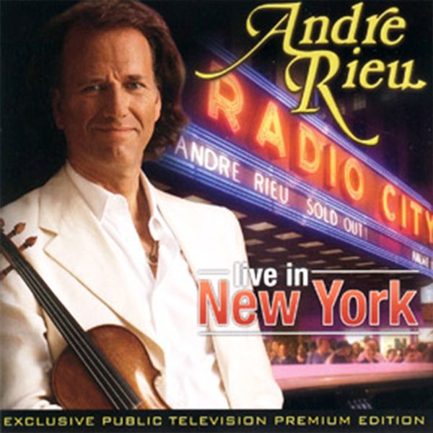 | 9:15  Stretch, tone and Balance  (45 Minutes)  11:00  “TGC”- The Louvre Ep.1  (30 minutes)  1:00  Exercise with Jeff  (1hr)  2:30  Live From Lincoln Center: 50 Years of Mostly Mozart  (1hr 30Minutes)  4:30  “TGC”- Americas Musical Heritage Ep.1  (30 minutes) | 11:00  “TGC”- TAI CHI Fitness work outs  Ep. 1  (1 hour)  1:00  “TGC”- Exploring the Milky Way  Ep. 1 &2  (1 hour)  2:30  Hamilton  (2hrs 40Min)  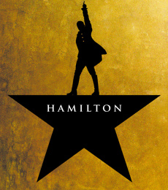 | 9:15  Stretch, tone and Balance  (45 Minutes)  11:00  “TGC”- 1066: the year that Changed Everything  EP 1  (30 minutes)  1:00  Exercise with Jeff  (1hr)  3:15  Zumba Gold  (1hr)  4:30  Reshowing of  Ginger Cove Church Service  (1 Hour) | 11:00  “TGC”- How to Stay Fit as you Age  Ep. 1&2 (1 hour)  1:00  “TGC”- George Orwell: A Sage for All Seasons Ep 1&2(1hr)  2:30  Hamilton  (2hrs 40Min)  7:00  Knives Out 2019  (2hrs.10Min.)  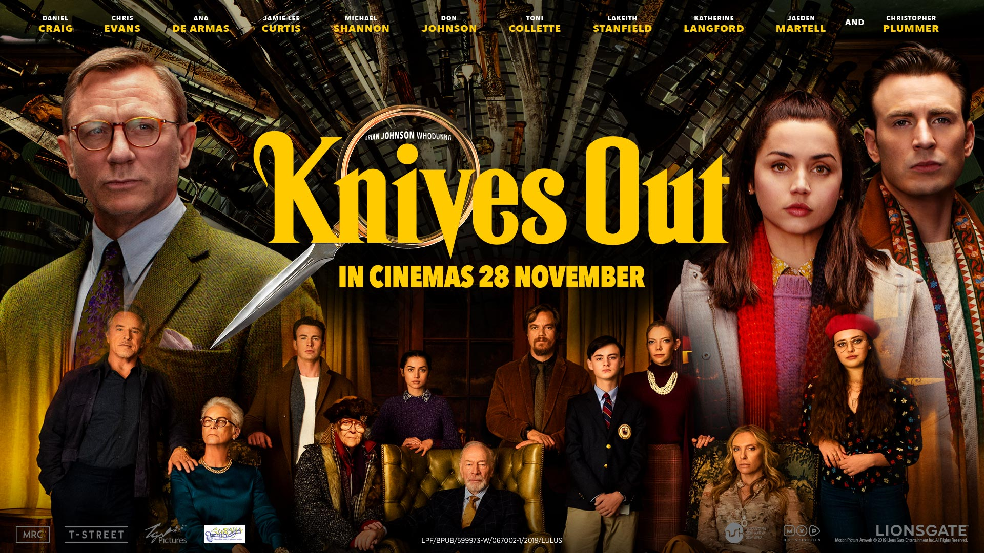 | 9:15  Stretch, tone and Balance  (45 Minutes)  11:00  “TGC”- Music as a Mirror of History Ep.1  (45 Minutes)  1:00  Exercise with Jeff  (1hr)  3:30  Grant Episode 1 (1hr 21mins.)   | 11:00  “TGC”- Practicing Mindfulness: An Introduction to Meditation Ep. 1&2  (1 hour)  1:00  “TGC”- Great Mythologies of the world Ep. 1&2  (1 hour)  2:30  Knives Out 2019  (2hrs.10Min.)
F
For questions or suggestions please contact Stephanie Baker at 410-224-8137 or Baker@gingercove.com

“TGC”- The Great Courses

Sunday | Monday | Tuesday | Wednesday | Thursday | Friday | Saturday
9 | 10 | 11 | 12 | 13 | 14 | 15

TV Channel 1970 Programing

11:00  Ginger Cove Church Service  (1 Hour)  1:00  “TGC”- Worlds Important Churches  Ep. 3&4  (1 hour)  4:00  “TGC”- The Cathedral  Ep. 3&4  (1 hour)  6:00  Andre Rieu Concert Series  (2hrs 15min) 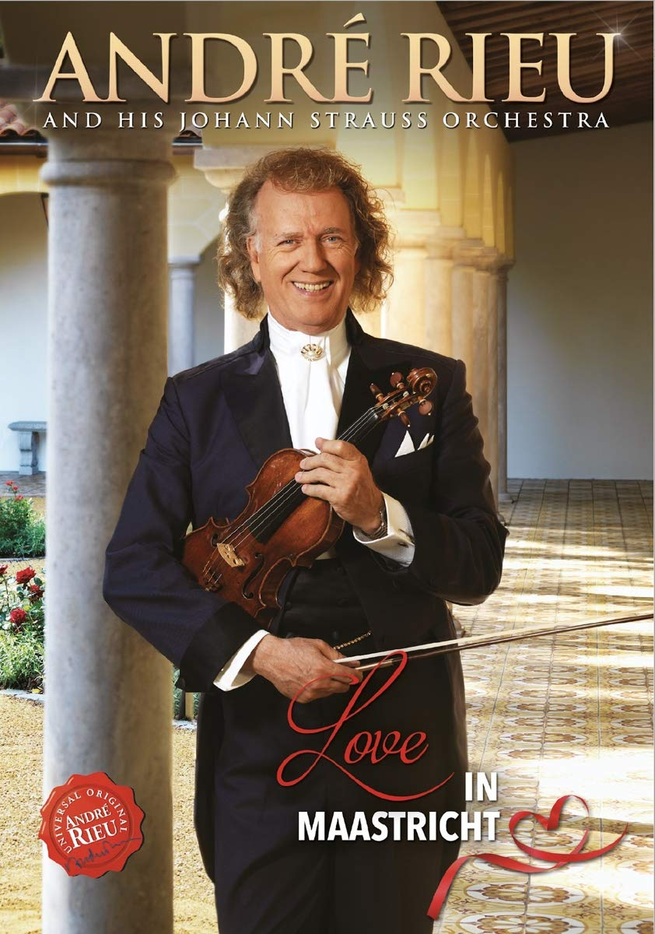 | 9:15  Stretch, tone and Balance  (45 Minutes)  11:00  “TGC”- The Louvre Ep.1  (30 minutes)  1:00  Exercise with Jeff  (1hr)  2:00  Harlem Renaissance Orchestra at Midsummer Night Swing  (2hrs 20Mins)  4:30  “TGC”- Americas Musical Heritage Ep.1  (30 minutes) | 11:00  “TGC”- TAI CHI Fitness work outs  Ep. 1  (1 hour)  1:00  “TGC”- Exploring the Milky Way  Ep. 3&4  (1 hour)  2:00  Gentle Stretch & Seated Yoga  (1 hour)  3:30  Military Wives (2020) 1hr. 53mins.   | 9:15  Stretch, tone and Balance  (45 Minutes)  11:00  “TGC”- 1066: the year that Changed Everything  EP 1  (30 minutes)  1:00  Exercise with Jeff  (1hr)  3:15  Zumba Gold  (1hr)  4:30  Reshowing of  Ginger Cove Church Service  (1 Hour) | 11:00  “TGC”- How to Stay Fit as you Age  Ep. 3&4  (1 hour)  1:00  “TGC”- George Orwell: A Sage for All Seasons Ep 3&4  (1hr)  3:15  TBD Movie  (1hr)  7:00  The Outpost (2020)  (2hrs 3Mins)   | 9:15  Stretch, tone and Balance  (45 Minutes)  11:00  “TGC”- Music as a Mirror of History Ep.1  (45 Minutes)  1:00  Exercise with Jeff  (1hr)  3:30  Grant Episode 1 (1hr 21mins.) | 11:00  “TGC”- Practicing Mindfulness: An Introduction to Meditation Ep. 3&4  (1 hour)  1:00  “TGC”- Great Mythologies of the world Ep. 3&4  (1 hour)  2:30  The Outpost (2020)  (2hrs 3Mins)
For questions or suggestions please contact Stephanie Baker at 410-224-8137 or Baker@gingercove.com

“TGC”- The Great Courses

Sunday | Monday | Tuesday | Wednesday | Thursday | Friday | Saturday
16 | 17 | 18 | 19 | 20 | 21 | 22

TV Channel 1970 Programing

11:00  Ginger Cove Church Service  (1 Hour)  1:00  “TGC”- Worlds Important Churches  Ep. 5&6  (1 hour)  4:00  “TGC”- The Cathedral  Ep. 5&6  (1 hour)  6:00  Andre Rieu Concert Series  (1hr 30mins)  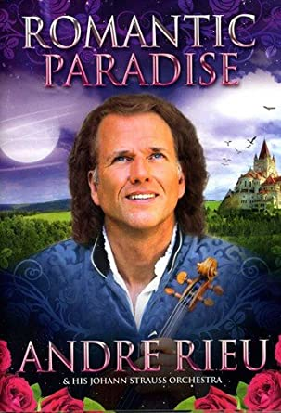 | 9:15  Stretch, tone and Balance  (45 Minutes)  11:00  “TGC”- The Louvre Ep.1  (30 minutes)  1:00  Exercise with Jeff  (1hr)  2:00  Lincoln Center’s American Songbook: Joe Iconis & Family  (2hrs)  4:30  “TGC”- Americas Musical Heritage Ep.1  (30 minutes) | 11:00  “TGC”- TAI CHI Fitness work outs  Ep. 1  (1 hour)  1:00  “TGC”- Exploring the Milky Way  Ep. 5&6  (1 hour)  2:00  Gentle Stretch & Seated Yoga  (1 hour)  3:00  TBD Movie | 9:15  Stretch, tone and Balance  (45 Minutes)  11:00  “TGC”- 1066: the year that Changed Everything  EP 1  (30 minutes)  1:00  Exercise with Jeff  (1hr)  3:15  Zumba Gold  (1hr)  4:30  Reshowing of  Ginger Cove Church Service  (1 Hour) | 11:00  “TGC”- How to Stay Fit as you Age  Ep. 3&4  (1 hour)  1:00  “TGC”- George Orwell: A Sage for All Seasons Ep 3&4  (1hr)  3:15  TBD Movie  7:00  TBD Movie | 9:15  Stretch, tone and Balance  (45 Minutes)  11:00  “TGC”- Music as a Mirror of History Ep.1  (45 Minutes  1:00  Exercise with Jeff  (1hr)  3:30  Grant Episode 1 (1hr 21mins.) | 11:00  “TGC”- Practicing Mindfulness: An Introduction to Meditation Ep. 5&6  (1 hour)  1:00  “TGC”- Great Mythologies of the world Ep. 5&6  (1 hour)  2:30  TBD Movie
For questions or Suggestions please contact Stephanie Baker at 410-224-8137 or Baker@gingercove.com

“TGC”- The Great Courses

Sunday | Monday | Tuesday | Wednesday | Thursday | Friday | Saturday
23 | 24 | 25 | 26 | 27 | 28 | 29

TV Channel 1970 Programing

11:00  Ginger Cove Church Service  (1 Hour)  1:00  “TGC”- Worlds Important Churches  Ep. 7&8  (1 hour)  4:00  “TGC”- The Cathedral  Ep. 7&8  (1 hour)  6:00  Andre Rieu Concert Series  (1hr)  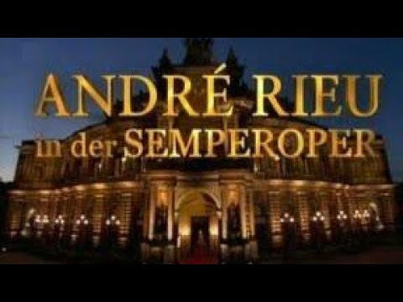 | 9:15  Stretch, tone and Balance  (45 Minutes)  11:00  “TGC”- The Louvre Ep.1  (30 minutes)  1:00  Exercise with Jeff  (1hr)  2:00  Simple Gifts: The Chamber Music Society of Lincoln Center at Shaker Village  (1hr 30 mins)  4:30  “TGC”- Americas Musical Heritage Ep.1  (30 minutes) | 11:00  “TGC”- TAI CHI Fitness work outs  Ep. 1  (1 hour)  1:00  “TGC”- Exploring the Milky Way  Ep. 7&8  (1 hour)  2:00  Gentle Stretch & Seated Yoga  (1 hour)  3:00  TBD Movie | 9:15  Stretch, tone and Balance  (45 Minutes)  11:00  “TGC”- 1066: the year that Changed Everything  EP 1  (30 minutes)  1:00  Exercise with Jeff  (1hr)  3:15  Zumba Gold  (1hr)  4:30  Reshowing of  Ginger Cove Church Service  (1 Hour) | 11:00  “TGC”- How to Stay Fit as you Age  Ep. 3&4  (1 hour)  1:00  “TGC”- George Orwell: A Sage for All Seasons Ep 3&4  (1hr)  3:15  TBD Movie  7:00  TBD Movie | 9:15  Stretch, tone and Balance  (45 Minutes)  11:00  “TGC”- Music as a Mirror of History Ep.1  (45 Minutes  1:00  Exercise with Jeff  (1hr)  3:30  TBD Movie | 11:00  “TGC”- Practicing Mindfulness: An Introduction to Meditation Ep. 7&8  (1 hour)  1:00  “TGC”- Great Mythologies of the world Ep. 7&8  (1 hour)  2:30  TBD Movie
For questions or Suggestions please contact Stephanie Baker at 410-224-8137 or Baker@gingercove.com

“TGC”- The Great Courses

 |  |   TV Channel 1970 Programing
  Sunday | Monday | Tuesday | Wednesday | Thursday | Friday | Saturday
  30 | 31 | 1 | 2 | 3 | 4 | 5
11:00  Ginger Cove Church Service  (1 Hour)  1:00  “TGC”- Worlds Important Churches  Ep. 9&10  (1 hour)  4:00  “TGC”- The Cathedral  Ep. 9&10  (1 hour)  6:00  Andre Rieu Concert Series  (1hr 15Min)   | 9:15  Stretch, tone and Balance  (45 Minutes)  11:00  “TGC”- The Louvre Ep.1  (30 minutes)  1:00  Exercise with Jeff  (1hr)  2:00  BBC Proms 2011 Hooray for Hollywood  (2hrs)  4:30  “TGC”- Americas Musical Heritage Ep.1  (30 minutes) | 11:00  “TGC”- TAI CHI Fitness work outs  Ep. 1  (1 hour)  1:00  “TGC”- Exploring the Milky Way  Ep. 9 &10  (1 hour)  2:00  Gentle Stretch & Seated Yoga  (1 hour)  3:00  TBD Movie | 9:15  Stretch, tone and Balance  (45 Minutes)  11:00  “TGC”- 1066: the year that Changed Everything  EP 1  (30 minutes)  1:00  Exercise with Jeff  (1hr)  3:15  Zumba Gold  (1hr)  4:30  Reshowing of  Ginger Cove Church Service  (1 Hour) | 11:00  “TGC”- How to Stay Fit as you Age  Ep. 3&4  (1 hour)  1:00  “TGC”- George Orwell: A Sage for All Seasons Ep 3&4  (1hr)  3:15  TBD  7:00  TBD | 9:15  Stretch, tone and Balance  (45 Minutes)  11:00  “TGC”- Music as a Mirror of History Ep.1  (45 Minutes  1:00  Exercise with Jeff  (1hr)  2:30  TBD Movie | 11:00  “TGC”- Practicing Mindfulness: An Introduction to Meditation Ep. 9&10  (1 hour)  1:00  “TGC”- Great Mythologies of the world Ep. 9&10  (1 hour)  2:30  TBD Movie
For questions or Suggestions please contact Stephanie Baker at 410-224-8137 or Baker@gingercove.com

“TGC”- The Great Courses

